**AWS:**

Instances:

On-demand

Reserved instance

Spot instance

Security:

VPC

Network ACLs

AWS IAM users and permissions

Security groups.

Storage:

AMAZON EBS – block storage.

Auto-scaling:

Metrics – N/W bandwidth, CPU, Custom  
  
Kafka in AWS,

EC2: Elastic cloud computing

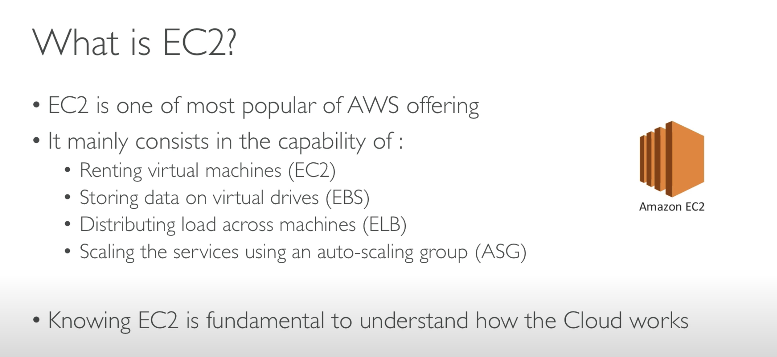

IAM: Identity and Access management

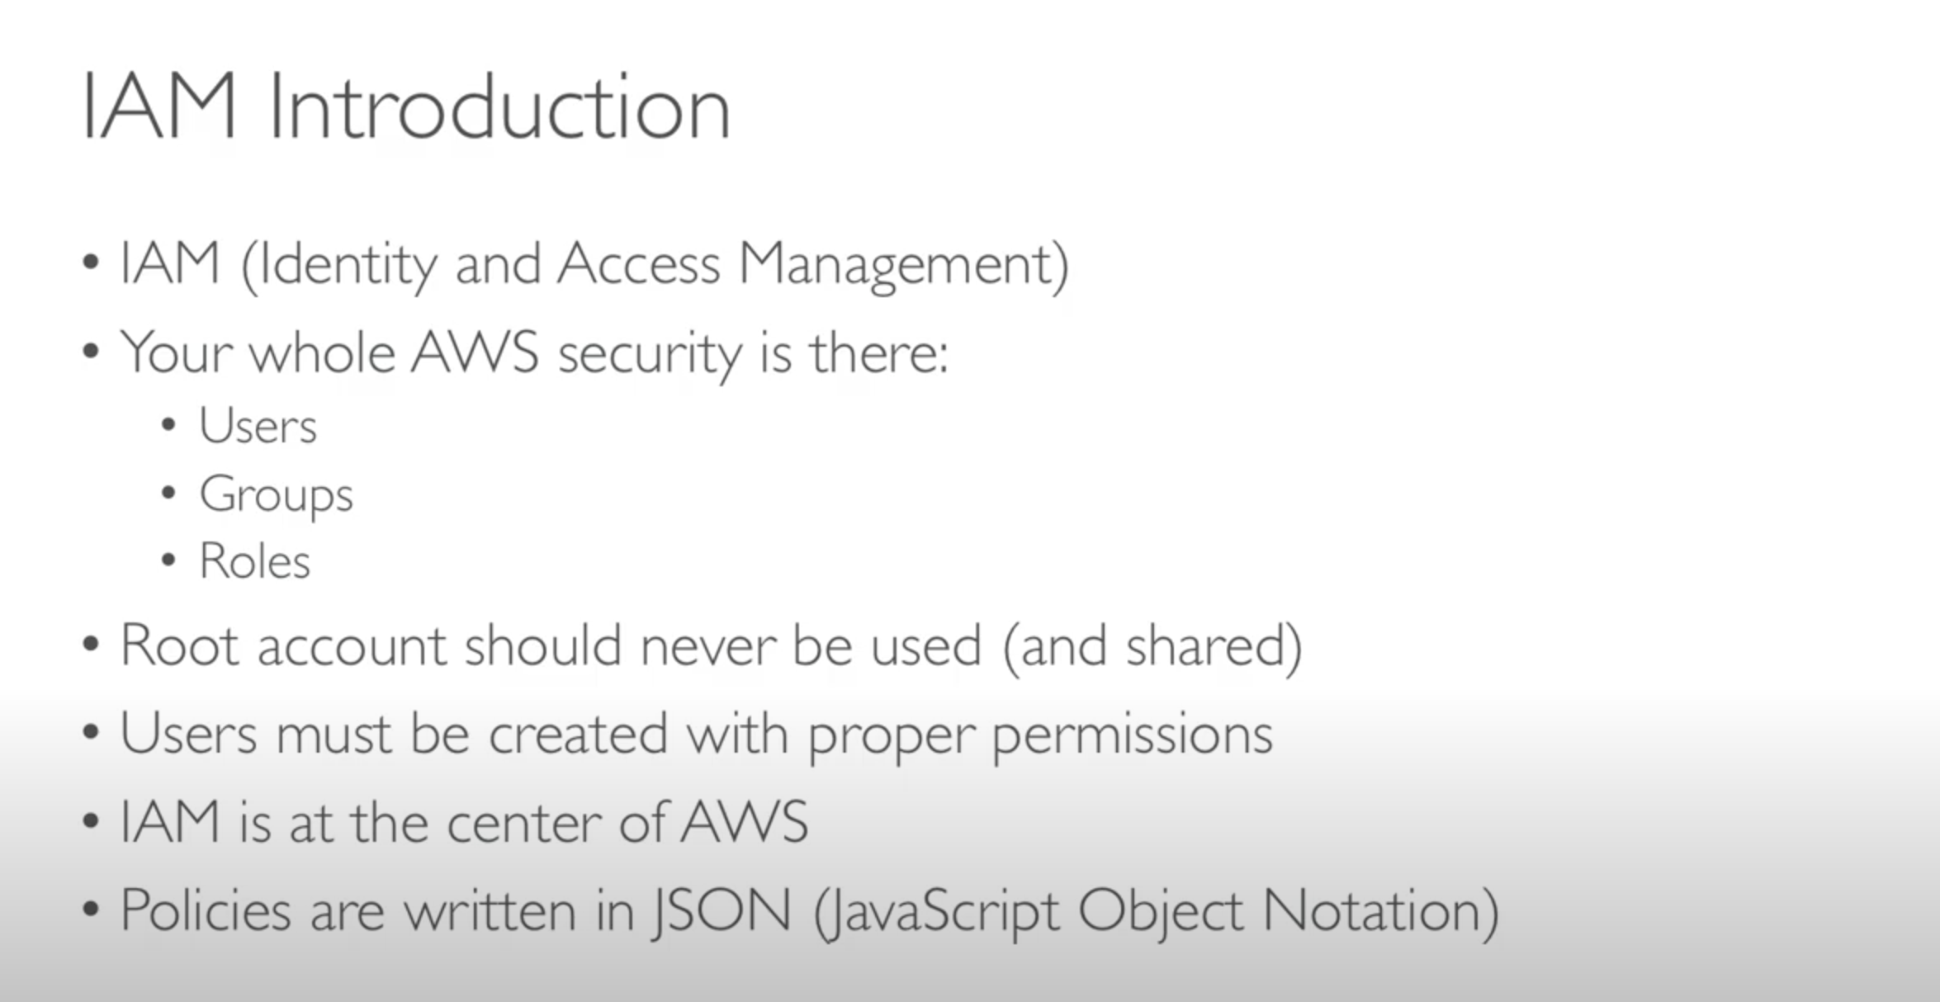

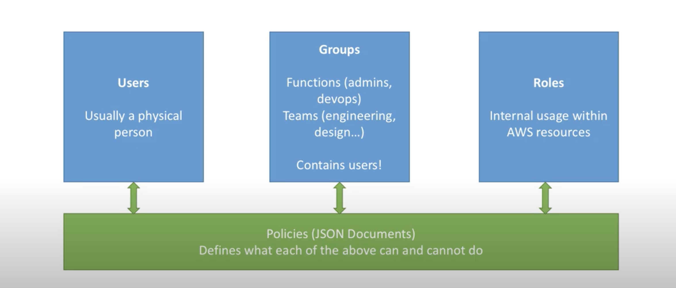

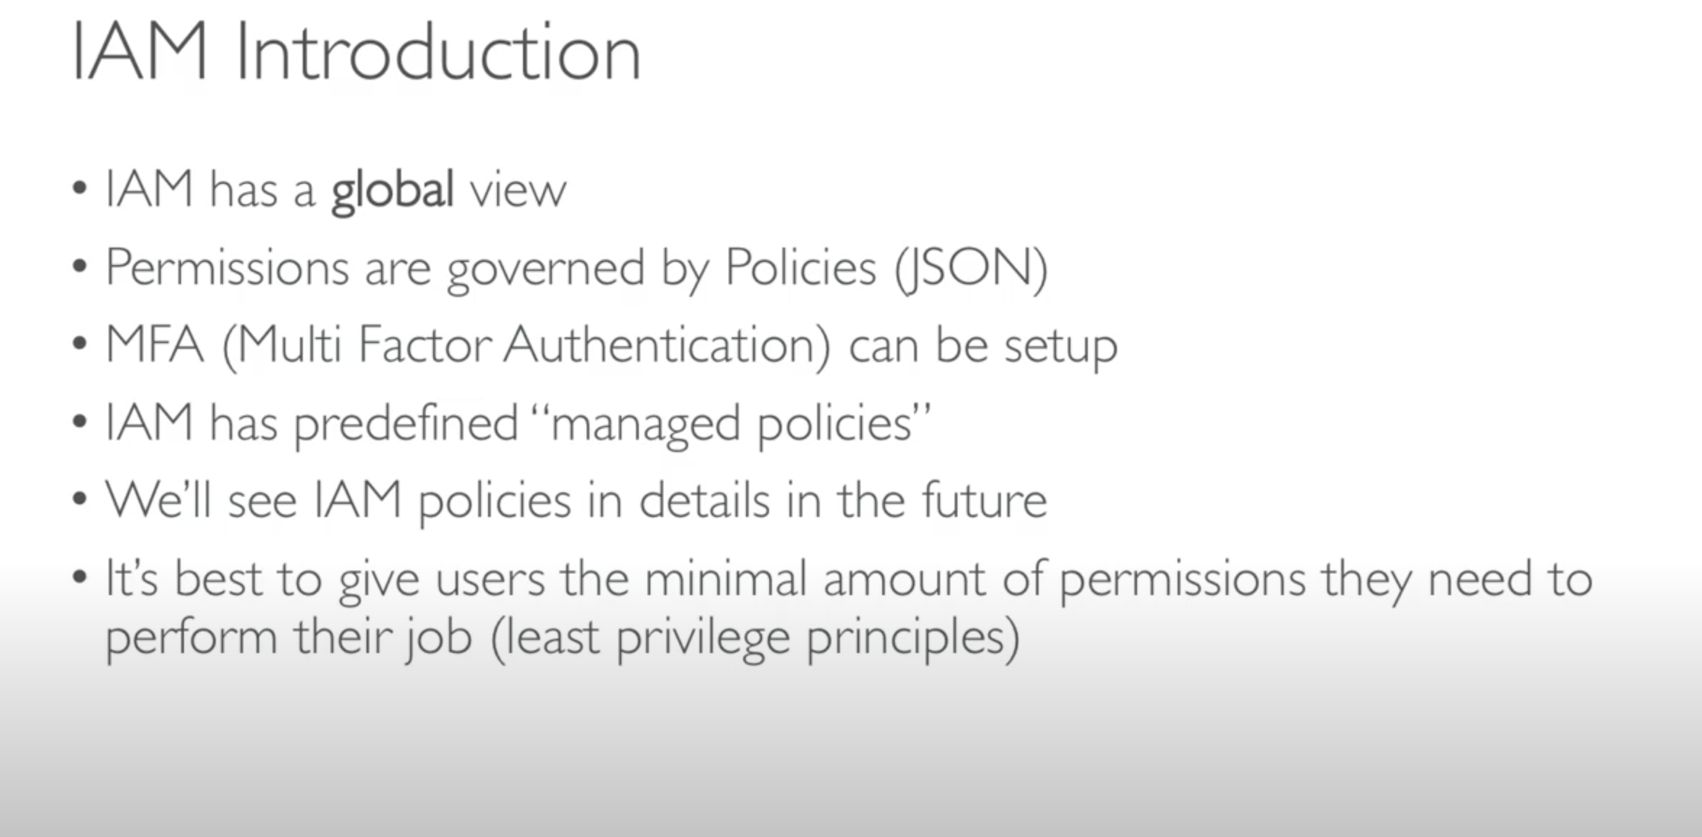

For big enterprises we use IAM Federation.

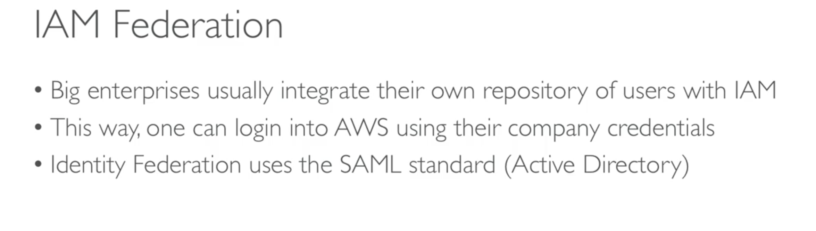

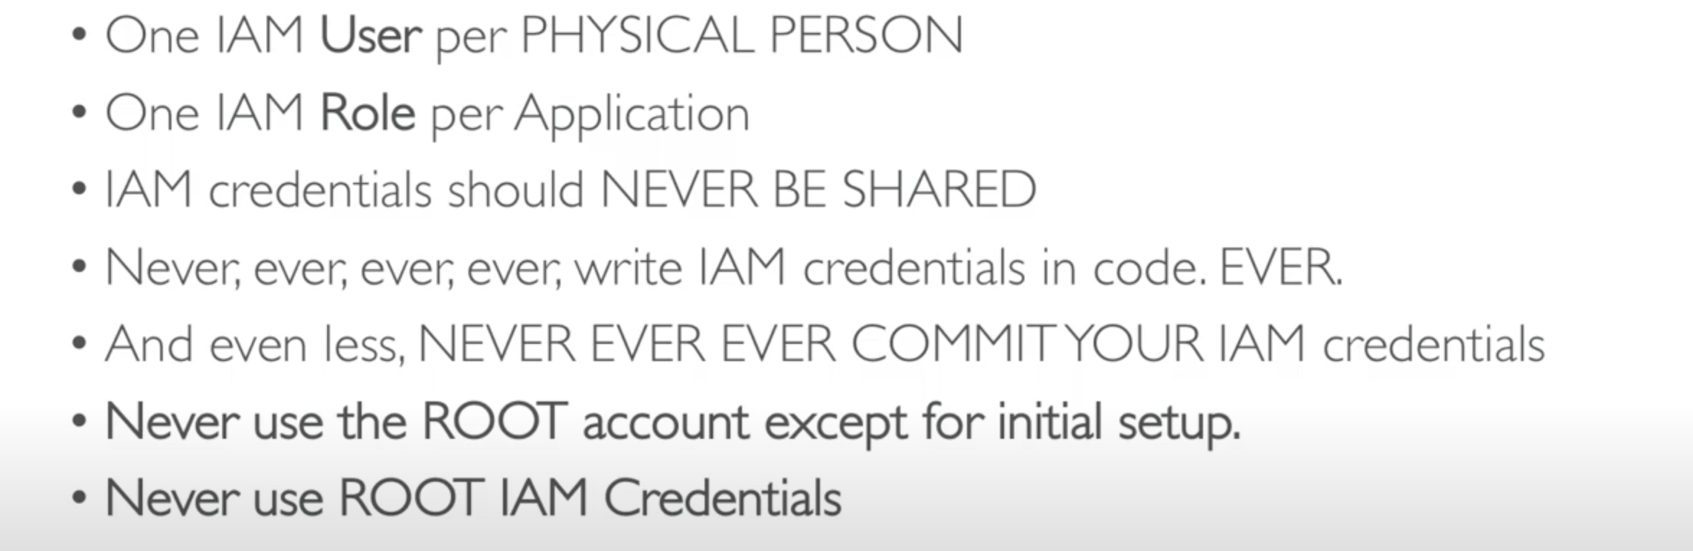

EC2 USER DATA:

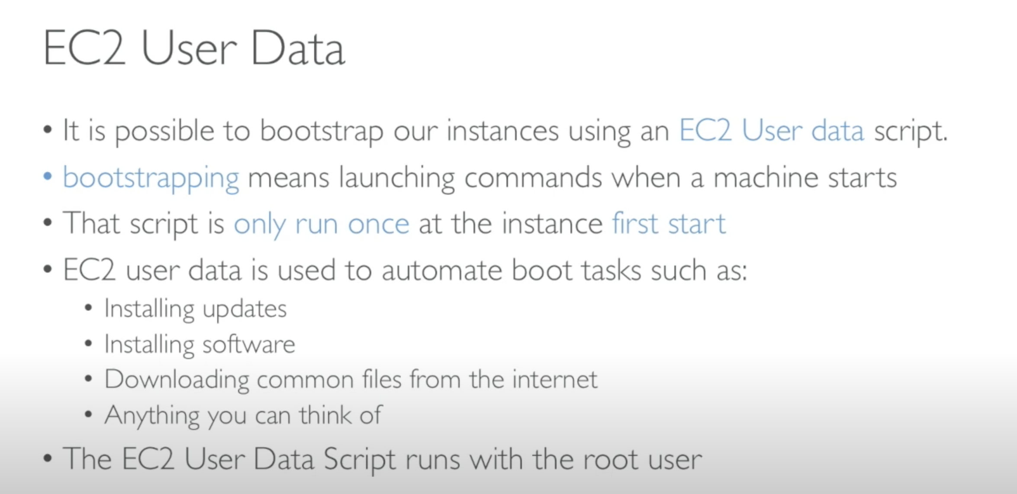

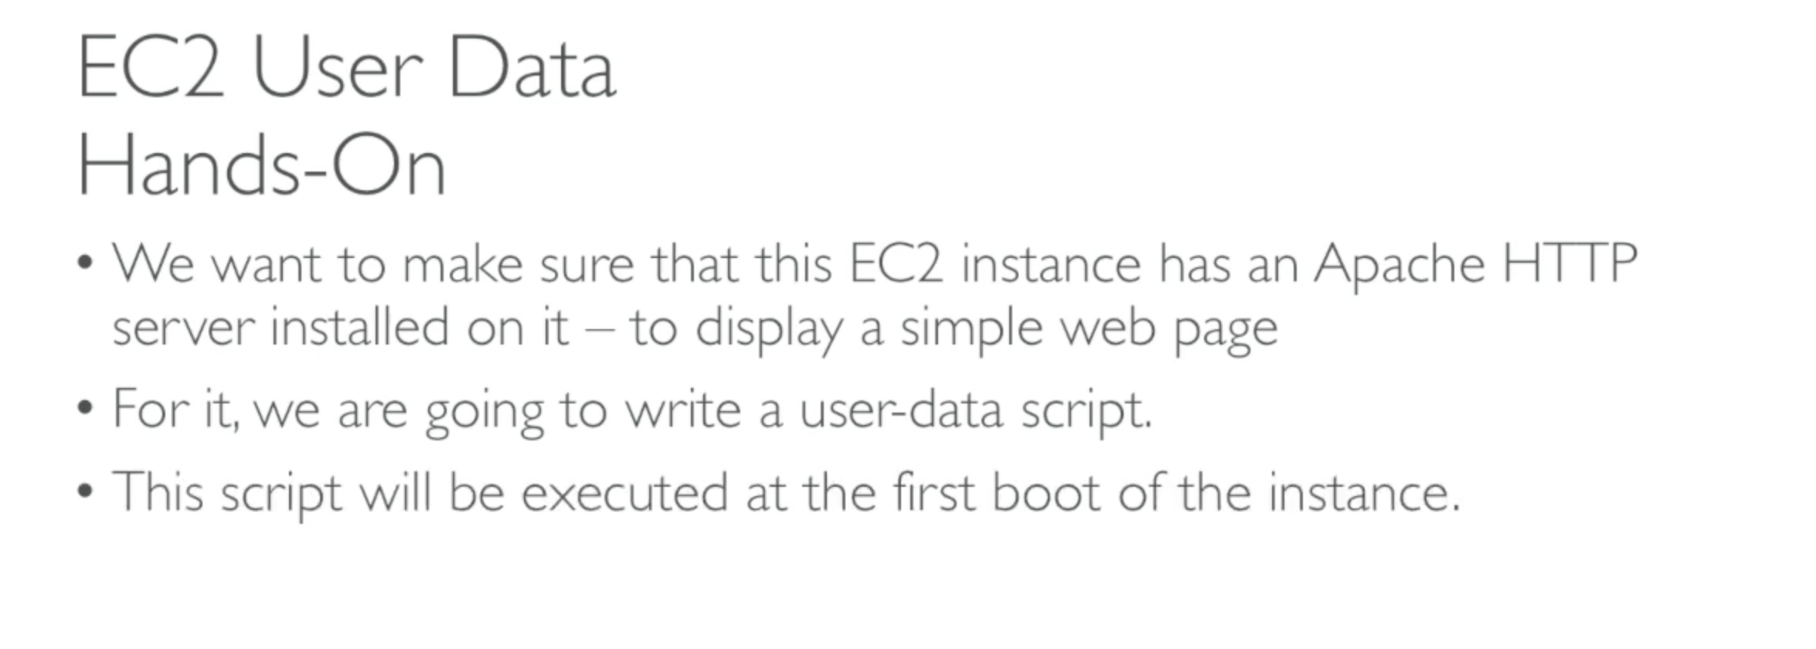

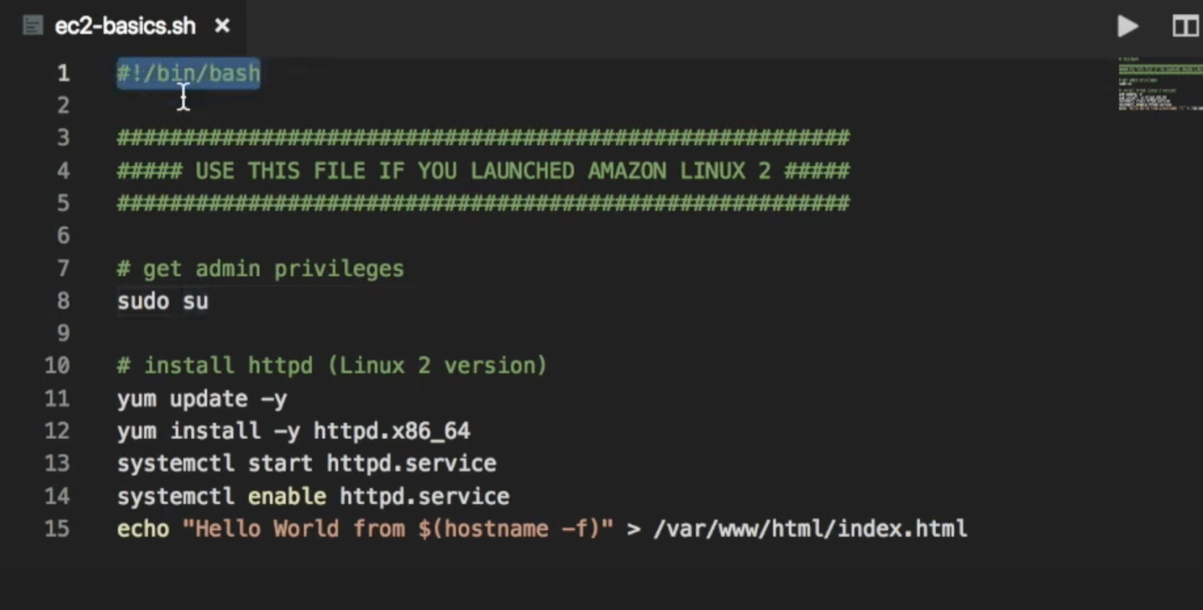

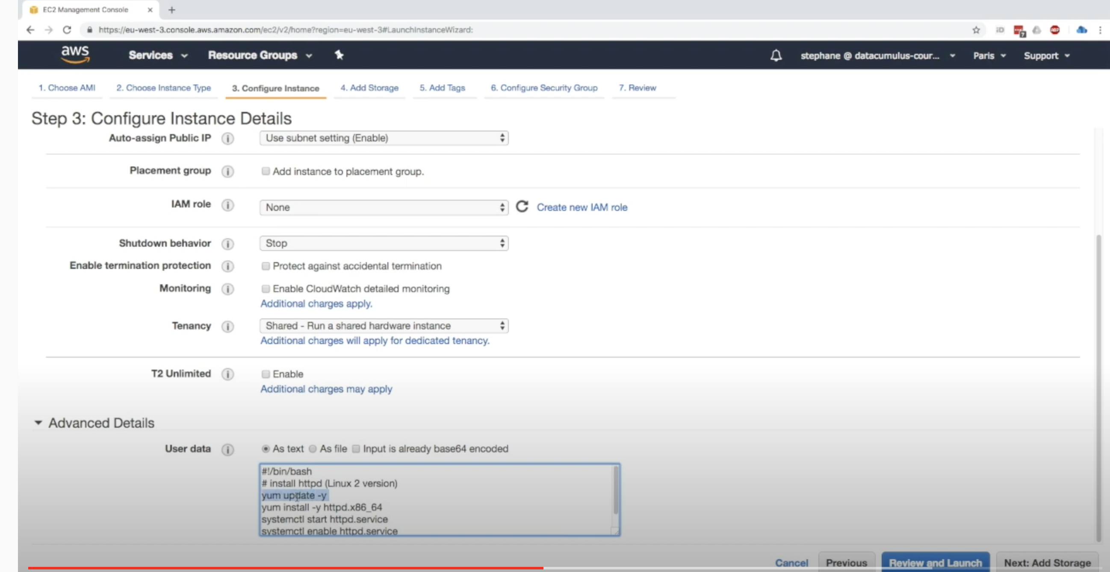

AMI:

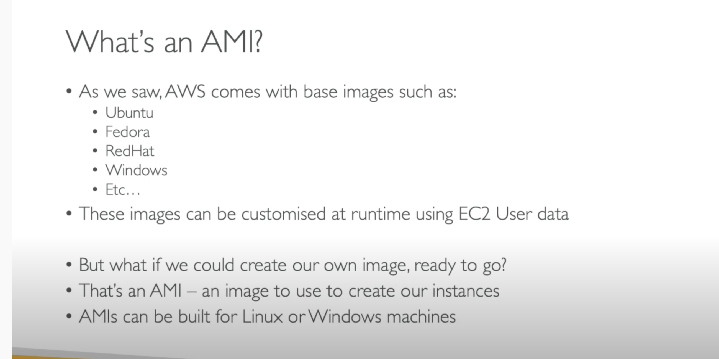

AMI’s created are confined to specific region they are not global.

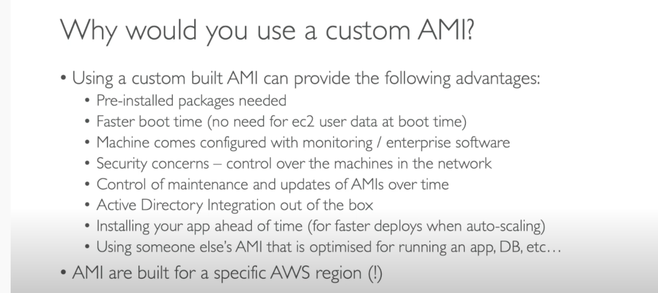

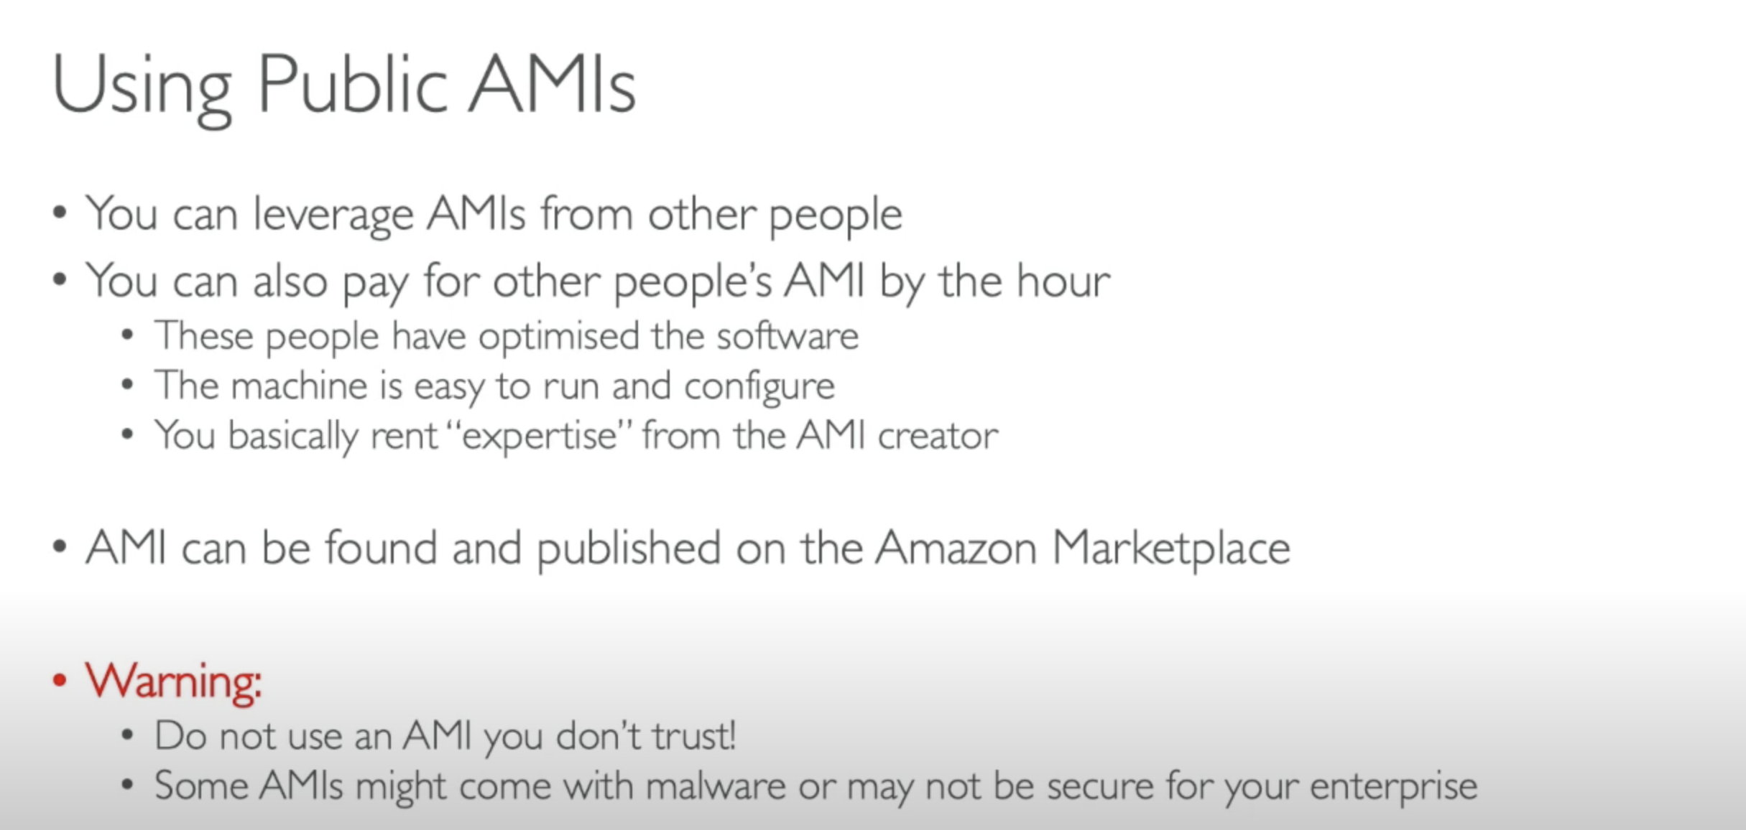

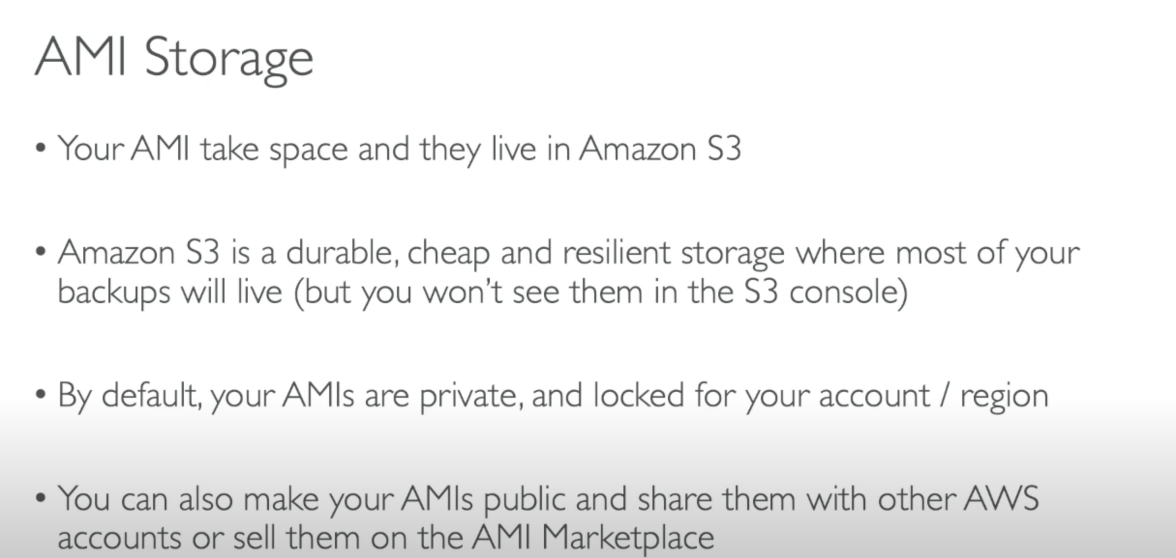

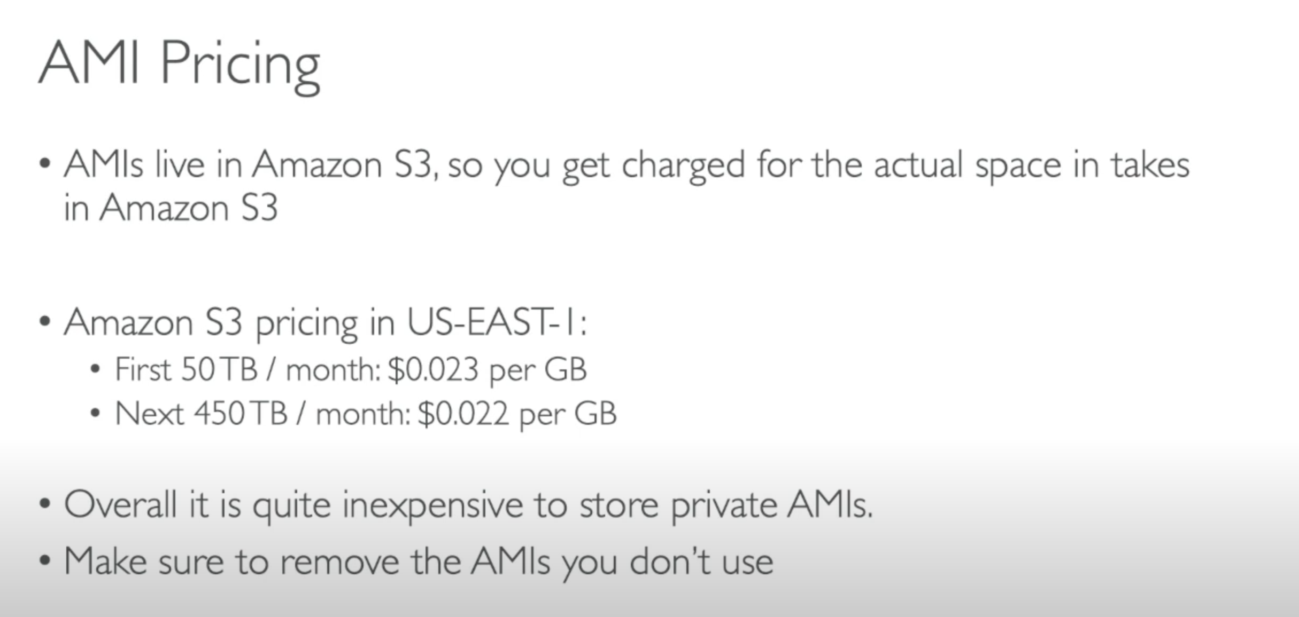

Introduction to security groups:

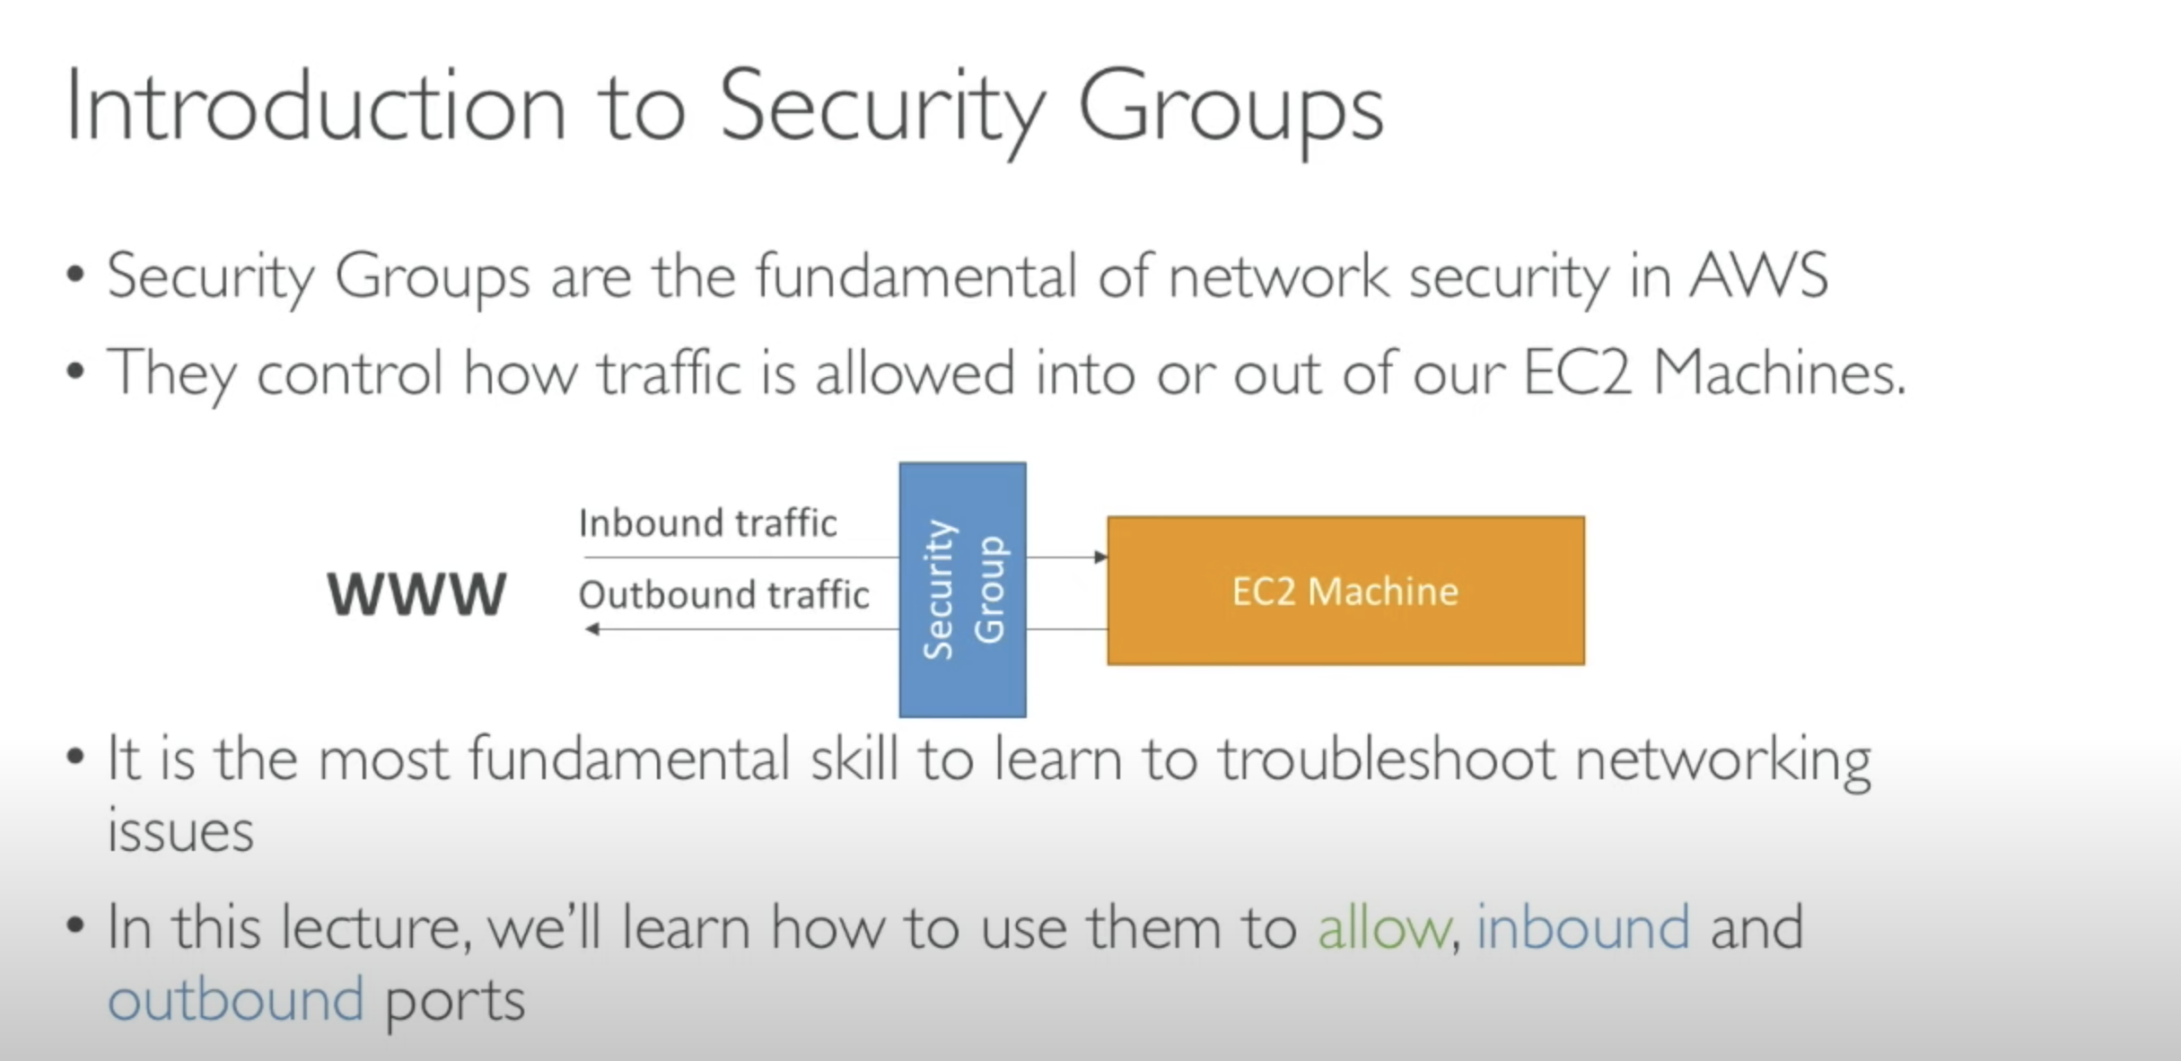

Introduction to cloud computing and AWS:

Why Cloud?

Olden days:

1. Buy a stack of servers
2. High Traffic? More servers
3. Monitoring and maintaining of servers

Servers are very costly.

Disadvantages:

If you consider costs then this setup I s expensive

Troubleshooting problems can be tedious and may conflict with your business goals.

Since the traffic is varying, your servers will be idle most of the time.

Upscaling & Downsacling was an Issue.

SERVICE MODELS:

IAAS - Infrastructure as a service. The whole infrastructure is provided to you. So that you can go ahead and create your own applications.

PAAS – Platform as service. Here you will be provided with a platform to build your own application. EX: Google app engine.

SAAS – s/w as a service. We are just consuming a service which is already maintained and handled by someone else. EX: Gmail.

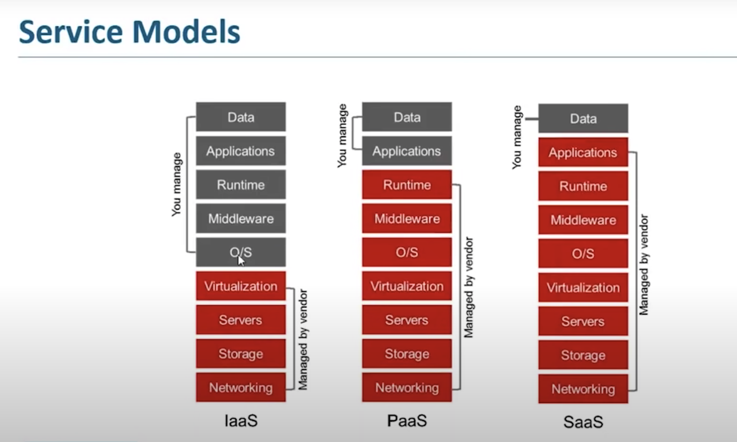

Deployment Models:

Diff types of clouds that are there in market –

1.public cloud 2.Private cloud 3.hybrid cloud

Cloud providers:

1.GCP

2.AWS

3.Azure

4.IBM cloud

5.DigitalOcean

6.terremark

Introduction to AWS:

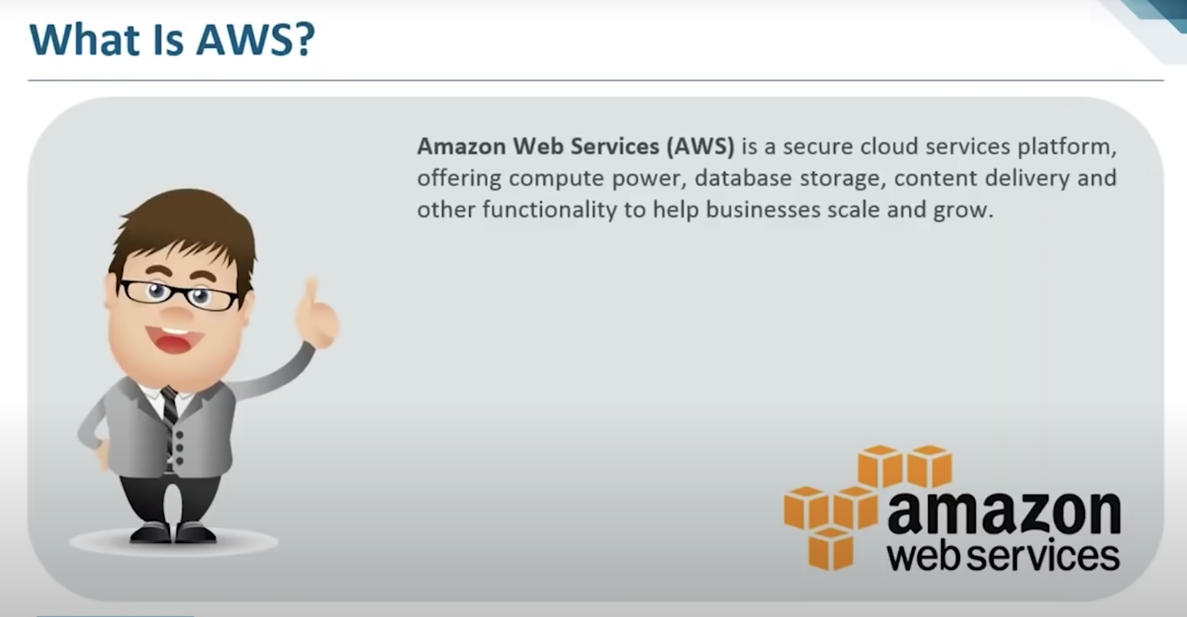

Advantages of AWS:

1.Flexibility

2.Cost effective

3.Scalability

4.Secuity

Automated scheduling

Various integrated APIs

AWS ARCHITECTURE:

Its Global architecture.

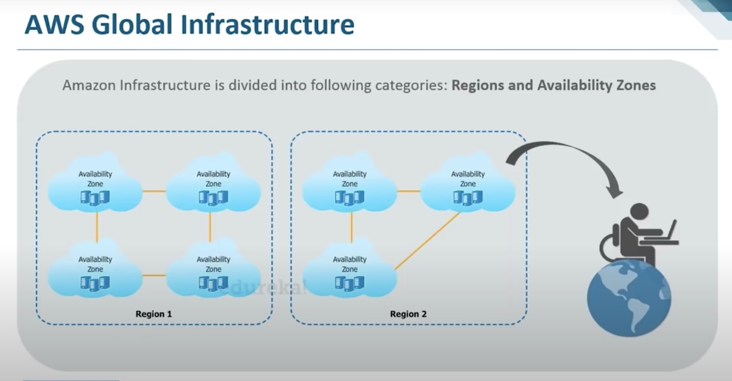

Domains of AWS:

Compute – EC2 : clean slate, EBS - lets you deploy various applications on AWS. Pre defined libraries

Migration – snowball

Security & compliance – IAM, - identification & authentication management toll, KMS – it lets you create your own public and private keys and that helps you keep your system secure.

Storage – S3 – bucket and object. these objects need to store in their route file which acts as the bucket basically. Cloud front – Which is nothing but your content delivery n/w. Glacier – It’s a place where we can store our Archives because it is highly affordable.

Networking – VPC: it is a virtual n/w which actually lets you move or launch your resources(AWS resources), Direct connect: you can think of it as least internet connection which can used within AWS, Route 53 – which is a DNS.

Messaging – Assured secured messaging and quite a few applications to care of that as well. We have cloud trail, opsworks (**configuration management service**). All these helps in messaging or communicating with other parties.

Database – Storage and database are similar but the diff. is storage is where you place your executable file. When we talk about databases we have Aurora which is very SQL like and it lets you perform various SQL options at a very faster rate. Which is 5 times faster than SQL. DynamoDB – which is a non-relational DBMS, helps you deals with unstructured data sources as well.

Managemant Tools – Cloud Watch: which lets you set alarams and act as montoring tool.

Compute services:

AWS EC2, Lambda, Elastic Beanstalk

AGENDA:

What is an instance?

AWS EC2 service

Types of EC2 service

Instance Pricing Models

Use case

Demo: Instances on AWS

Types of EC2 service:

General Purpose Instance –

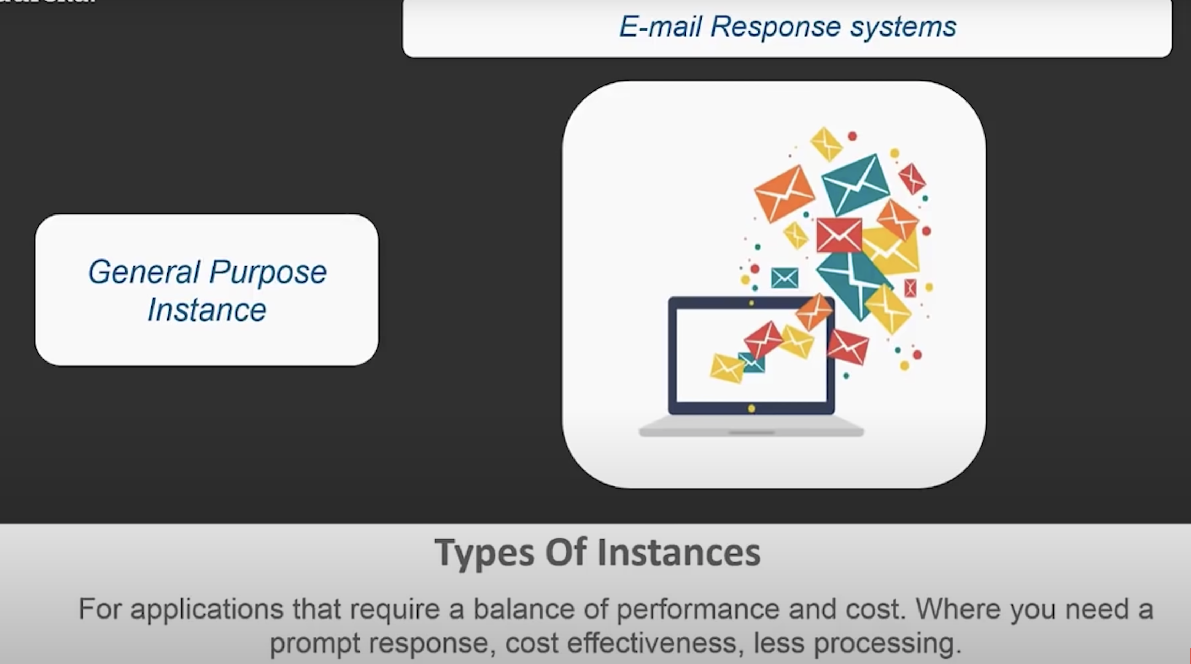

Compute Instance: For application that requires a lot of processing from the CPU.

Analysing streaming Data.

Memory Instance: For applications that are heavy in nature, therefore, require a lot of RAM.

Storage Instances: For applications that are huge in size or have a data set that occupies a lot of space. Large sized applications.

GPU instances: heavy graphics rendering like 3D modeling stuff.

EC2 pricing Models:

Involves a lot of palnning to save money.

On-Demand – demand and get it. Made available for limited time frame. Pre pay for mentioned hours and after that instance get terrminated

Dedicated – given to organization so that their security is defined better than other. Data privatise. Highly confidential data. Isolation from other vendors. Costlier.

On Spot – bidding, available for limited period of time. Instance terminates as price changes. Cheaper price. Good for volatile data only.

Reserved – renting an apt for lease for longer duration. Reserving instances for fixed period for fixed price.

Ec2 instances based on their functioning:

Burstable Instance – category of GPU, utilize cpu for certain %. This is good for it. CPU utilization is locked at particular %, if more CPU required then it will provide full utilization.(20% lock to 100% burstable)

EBS optimized – processing data at higher speed. High I/P, O/P processing.

Cluster Networking – they form clusters of instances. Different clusters of instances that serves different purposes.

Dedicated – more related to data security part.

Use case:

Analaysis of customers data – Bustable

Auto response Email system – need quick response at low cost, EBS optimized instances with IOPS would help me better.

Search engine and browsing – two diff things, will opt for clustered n/w instances.

Confidential data processing – Dedicated instances.

Demo:

AWS LAMBDA:

1.AWS Compute Domain

2.Why AWS Lambda?

3.AWS SDKs

4.Using AWS Lambda with Eclipse IDE

5.Demo

AWS Compute Doman:

Main services under it are

1.EC2

2.Elastic BeanStalk – which is automated version of EC2. EBS you won’t the access to the OS but you still have the control over the configuration you system. So you can choose what kind of a system you wanna launch. EBS is used to deploy an application. So basically you just upload your code and your application Is deployed on the AWS infrastructure.

3.AWS Lambda – An automated version of EC2 where you won’t get the access to OS. With AWS Lambda you don’t even have a choice to choose what kind of configuration you want with your server. With AWS Lambda you Just need to upload your code and it executes it.

Why do we have AWS Lambda service when we have AWS Elastic Beanstalk?

With AWS Lambda you can only execute background tasks, you cannot deploy an application.

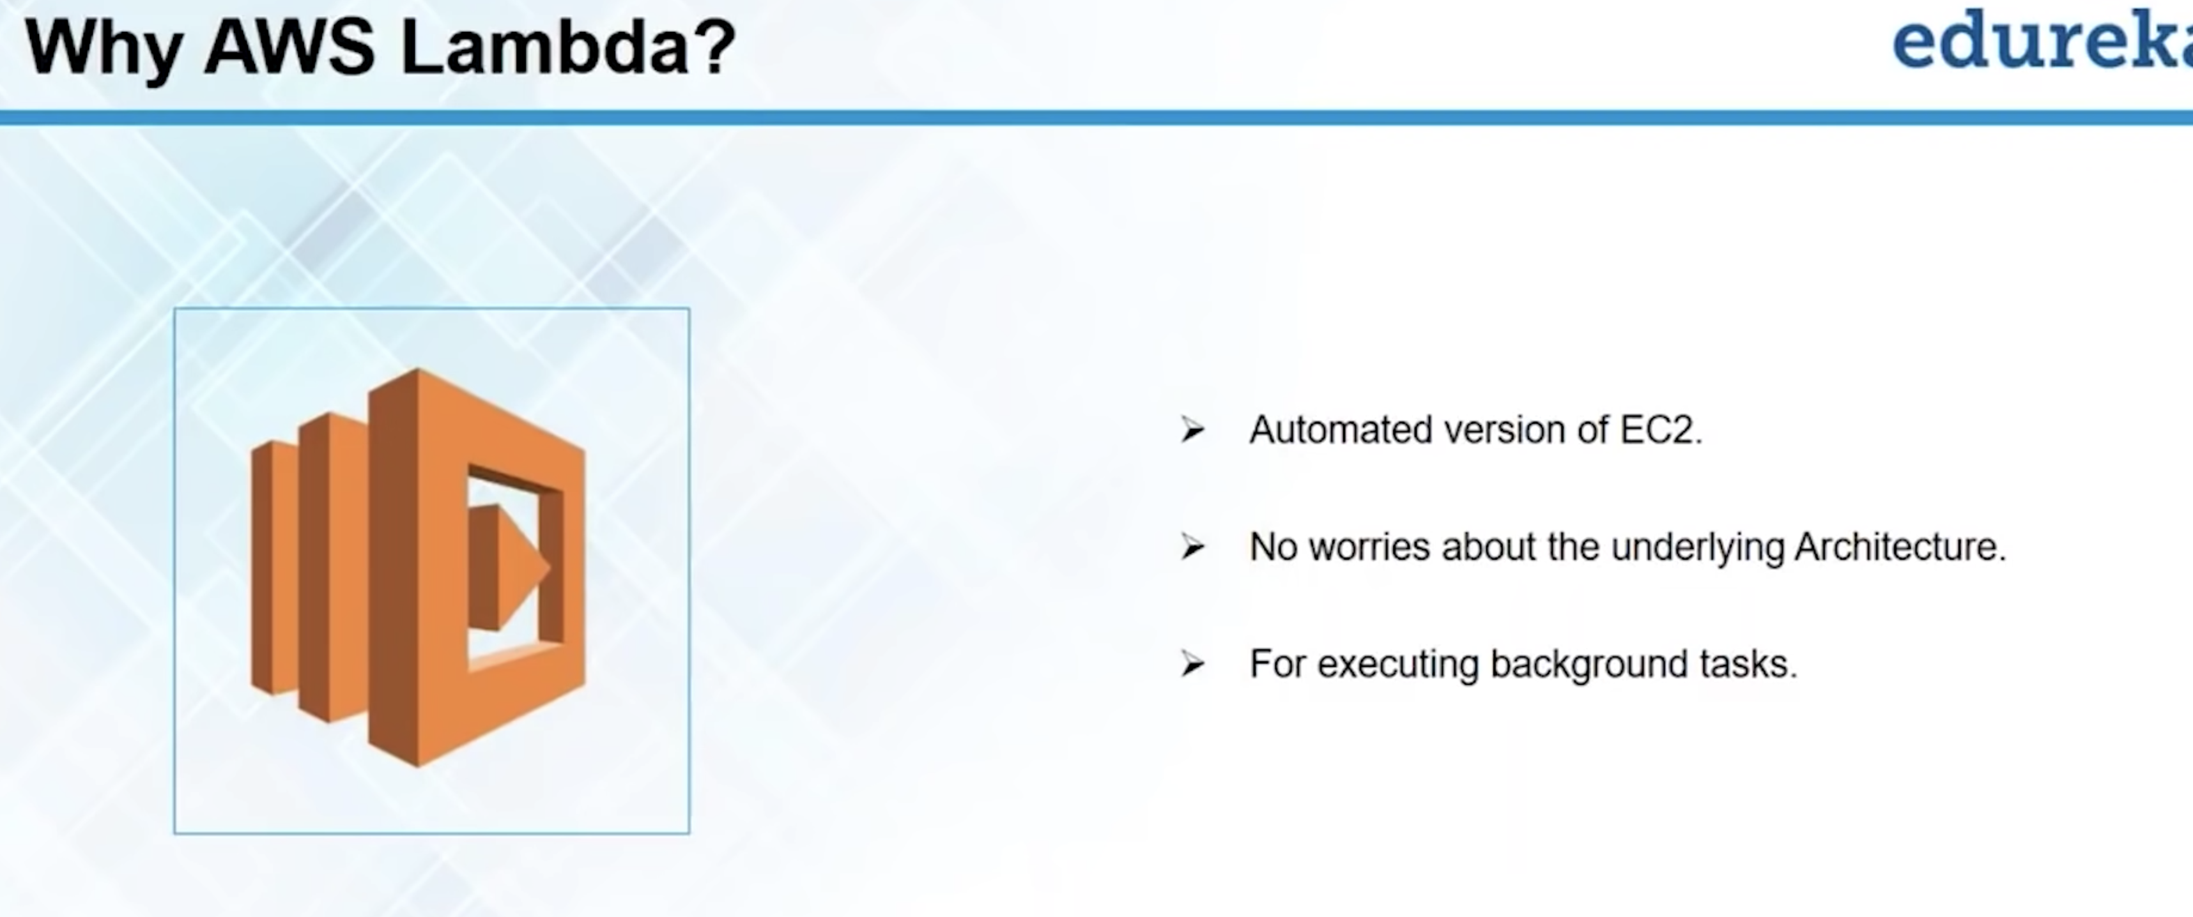

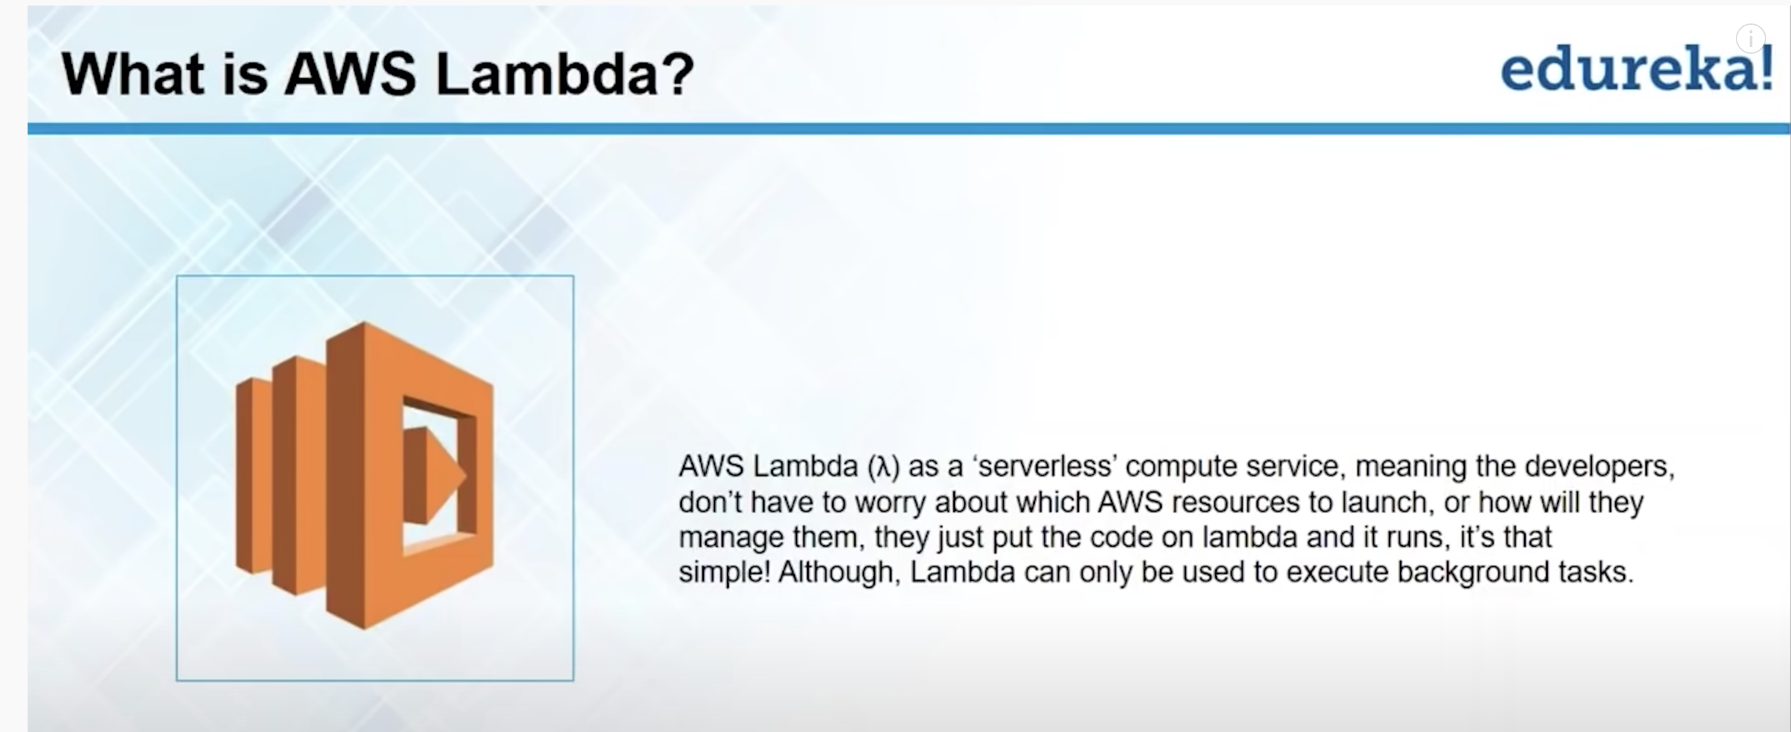

How we can use Aws Lambda:

You can use the service by s/w developments kits(SDKs) that is provided by AWS.

The SDKs are basically APIs which are used by developers to connect to desired service they want.

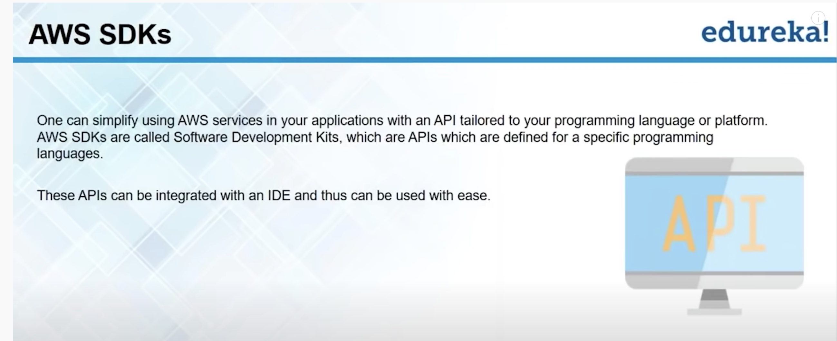

These SDKs are used with IDEs. Currently there are two IDEs which are supported

1. Eclipse
2. Visual Studio

Using AWS Lambda with Eclipse IDE:

We need to configure or code our AWS function on Java. That is the reason we are using eclipse.

Install Eclipse on your system and on help option click on install new s/w and provide aws URL.

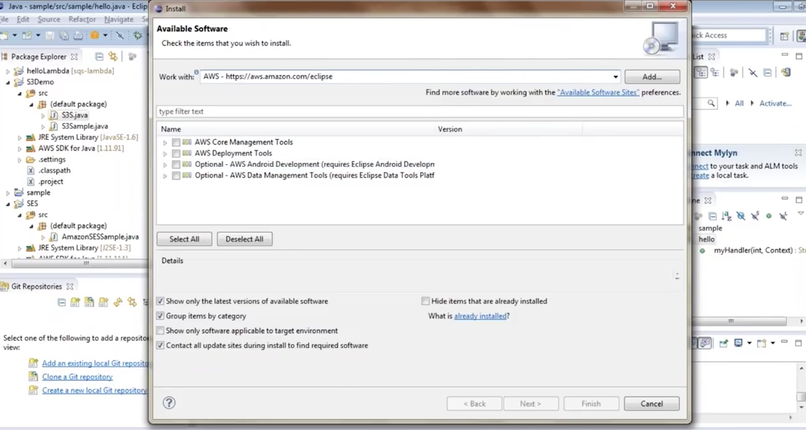

This is how we install SDKs with IDE.

DEMO:

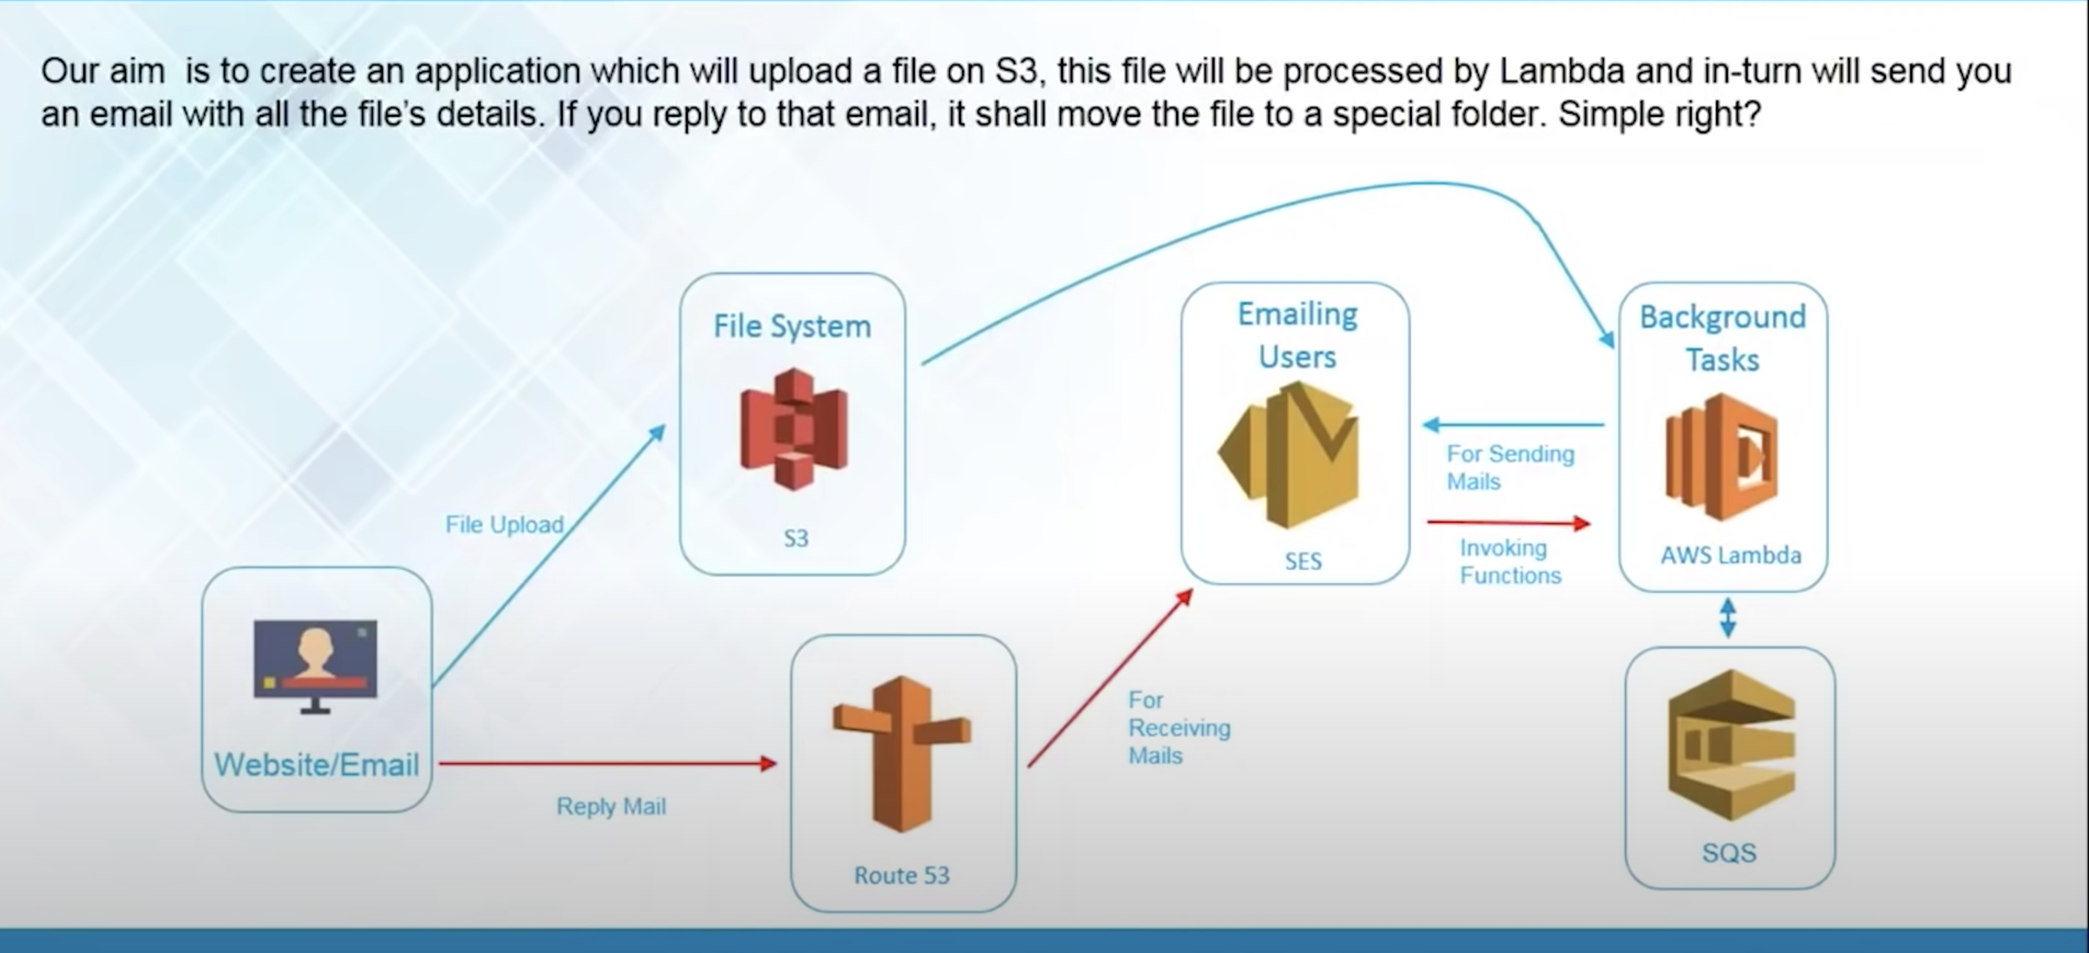

Go to S3 – DEMO BUCKET – properties – EVENTS – Add notification – provide details

Name – AWS-LAMBDA

Events – Put(upload event)

Send to – Lambda Function

Lambda – MyFunction(your Function Name)

SAVE

You might get an error over here saying you might not have sufficient permissions. In that case you will an ADD PERMISSIONS. Click it, if will take care of permissions.

The above error comes because your lambda function may not have permissions to get notifications from S3.

Now we have configured our S3 to invoke Lambda Function once a file is uploaded to S3.

Now our lambda is already configured to Interact with SES Through the code.

Lets configure SQS. Simple Queue Service. We have to create a Queue in SQS in which our website will be uploading the files.

Go to SQS – Create New Queue (FIFO Queue)

QUEUE NAME – hello-lambda.fifo (since we selected FIFO queue)

Click on QUICK CREATE QUEUE

My queue hello-lambda.fifo will be created and we need to configure it to whenever msg comes in it gets automatically deleted after 2 mins.

Select QUEUE ACTION – Congigure queue –

Message retention Period – 2 mins – Save changes

Lets configure SES now.

You can configure your email to receive emails. Go to SES and add email there.

Now we also need to configure sender email in SES.

For that we need a valid domain name.

We can create a free domain name in my.dot.tk

After creating Domain name.   
  
In AWS go to domains and verify the created Domain there. And we will get 2 records. We will enter these 2 records in DNS server. So that the domain name created has to point to a DNS server.

Now how will you point created Domain name to the DNS server.

DNS server is basically route 53. We will be configuring route53 to the create Domain name.

Open Route53 in AWS – DNS management – Get started now – Create Hosted Zone – provide created domain name and click on create. We have created a hosted zone in Route53.   
Now I have to connect this domain to route53.

On domain page click – Manage Domain – Management Tools – Name servers   
you need to provide the name servers created in Hosted Zone here. (please remember don’t give the . at the end of the NS provided) – save. Changes should save successfully.

Now domain name Is pointing to Route53

Now in route53 we need to include the records which we got in AWS Domains.

Go to Route53 and click on CREATE RECOND SET

TYPE : MX Mail Exchange

Value – paste value from records ---- Create

Now we have MX record

Now we have to create one more record set . copy name from record and paste it on create record NAME

TYPE: TXT

Value: Copy from records

Now my route53 is now configured to receives emails from created domain.

Go to SES page and refresh, you can see your Domain Name got verified.

you can go back to SES and click on Email receiving: Rule Set.

Here we need to create a new rule set .

Here I have to specify a recipient – provide a email to send emails.(email with domain name)

Add ACTION: Lambda  
  
Lambda : myFunction2

Next step

RULE NAME: Lambda-demo

Next Step – Create Rule

So now rule set will be enabled